Multi Agency Hoarding Tool Kit for Practitioners

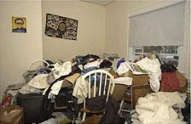
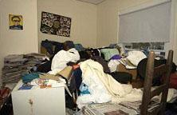
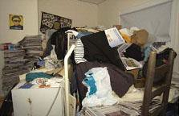
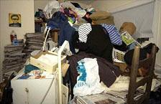
Clutter Image Rating Scale - Bedroom

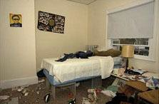
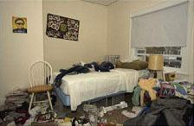
Please select the photo that most accurately reflects the amount of clutter in the room

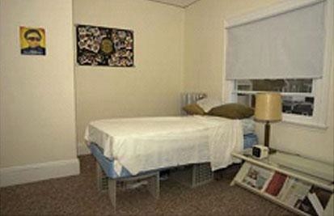

1 | 2 | 3

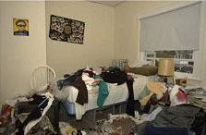

4 | 5 | 6

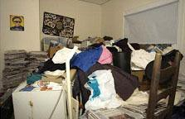

7 | 8 | 9

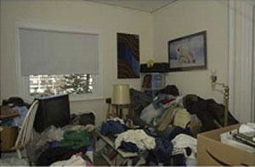
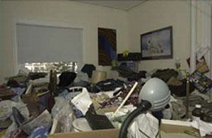
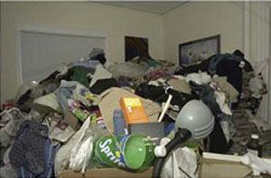
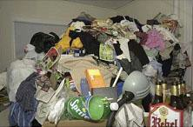
Clutter Image Rating Scale - Lounge

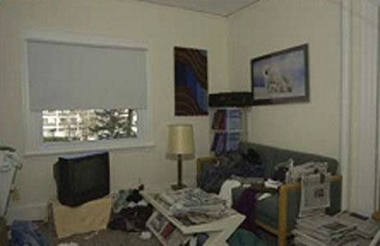
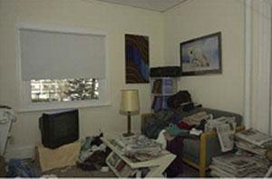
Please select the photo that most accurately reflects the amount of clutter in the room

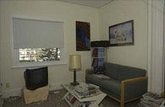

1 | 2 | 3

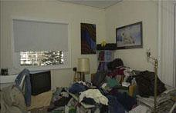

4 | 5 | 6

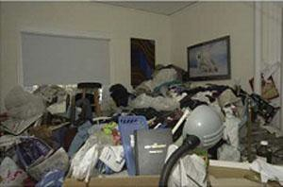

7 | 8 | 9

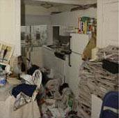
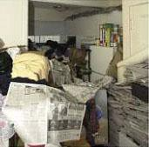
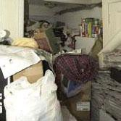
Clutter Image Rating Scale – Kitchen

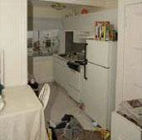
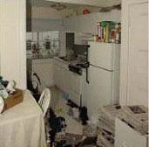
Please select the photo that most accurately reflects the amount of clutter in the room

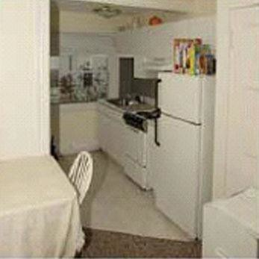

1 | 2 | 3

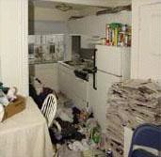

4 | 5 | 6

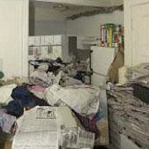

7 | 8 | 9

Practitioners Hoarding Assessment

This assessment should be completed using the information you have gained using the Practitioners Guidance Questions. Complete this review away from the clients‟ property and in conjunction with the Multi Agency Hoarding Protocol Assessment Tool. Text boxes will expand to allow further text

Date of Home
Assessment
Clients Name
Clients Date of Birth
Address
Clients contact details
Type of dwelling
Freeholder | Yes | Tenant – Name & address of landlord  if local authority tenant referrer to contact Blackpool Housing
Household Members |  | Name |  | Relationship | DOB
Pets – indicate what
pets and any concerns
Agencies currently involved – with contact details
Non agency support
currently in place
Clients attitude towards hoarding

Please indicate if present at the property
Structural damage to property |  |  | Insect or rodent infestation |  |  | Large number of animals |  |  | Clutter outside
Rotten food |  |  | Animal waste in house |  |  | Concerns over  the cleanliness of the property |  |  | Visible human faeces
Concern of self- neglect |  |  | Concerned for children at the property |  |  | Concerned for other adults at the property
Using the Clutter Image scale please score the each of the rooms below
Bedroom 1 |  |  |  | Bedroom 4 |  |  | Separate toilet
Bedroom 2 |  |  |  | Kitchen |  |  | Lounge
Bedroom 3 |  |  |  | Bathroom |  |  | Dining Room
Please refer to the Multi Agency Hoarding Protocol. Provide a Description of the Hoarding Problem:
(presence of human or animal waste, rodents or insects, rotting food, are utilities operational, structural damage, problems with blocked exits, are there combustibles, is there a fire risk? etc.)
Please refer to the Multi Agency Hoarding Protocol Tool, based on the information provided
above, what level is your case graded?
Level 1- Green |  |  |  | Level 2 - Orange |  |  | Level 3 - RED
Name of the practitioner
undertaking assessment
Name of Organisation
Contact details
Next action to be taken
List agencies referred to with
dates & contact names

HOARDING SELF – ASSESSMENT
Complete this form at the start and at the end of your work with Outside The Box.
Thoughts | Not at all Very much
Do you focus on every part of an item and find unusual detail that others may not see? | 0 1 2 3 4 5 6 7 8 9 10
Do you generate lots of ideas when thinking about the use of items? | 0 1 2 3 4 5 6 7 8 9 10
Do you focus on the non-essential detail of items? | 0 1 2 3 4 5 6 7 8 9 10
How much do you think that hoarding would contribute to being a fire risk in your property? | 0 1 2 3 4 5 6 7 8 9 10
Feelings | Not at all Very much
Do you feel distressed when you imagine discarding items that you feel might have a use? | 0 1 2 3 4 5 6 7 8 9 10
Do you often desire an item even if you already have an item that performs the same function? | 0 1 2 3 4 5 6 7 8 9 10
Do you often desire an item even if you do not have sufficient available space to accommodate the item? | 0 1 2 3 4 5 6 7 8 9 10
Do you often feel the need to save items because they might have a use? | 0 1 2 3 4 5 6 7 8 9 10
Behaviours | Not at all Very much
Do you have difficulty discarding possessions regardless of their value? | 0 1 2 3 4 5 6 7 8 9 10
Do you have difficulty organising all your possessions? | 0 1 2 3 4 5 6 7 8 9 10
Do you often rely on visual clues to remember things? | 0 1 2 3 4 5 6 7 8 9 10
Do you often have problems deciding what to do with an item? | 0 1 2 3 4 5 6 7 8 9 10

Guidance Questions for Practitioners- these can be used in addition to the tool kit to gather information when a rapport has been built or it is appropriate.

Listed below are examples of questions to ask where you are concerned about someone’s safety in their own home, where you suspect a risk of self- neglect and hoarding?

The information gained from these questions will inform a Hoarding Assessment see appendix and provide the information needed to alert other agencies.
Most clients with a hoarding problem will be embarrassed about their surroundings so adapt the question to suit your customers.

  - How do you get in and out of your property, do you feel safe living here?
  - Have you ever had an accident, slipped, tripped up or fallen? How did it happen?
  - How have you made your home safer to prevent this (above) from happening again?
  - How do move safely around your home ( where the floor is uneven or covered, or there are exposed wires, damp, rot, or other hazards)
  - Has a fire ever started by accident?
  - How do you get hot water, lighting, heating in here? Do these services work properly? Have they ever been tested?
  - Do you ever use candles or an open flame to heat and light here or cook with camping gas?
  - How do you manage to keep yourself warm? Especially in winter?
  - When did you last go out in your garden? Do you feel safe to go out there?
  - Are you worried about other people getting in to your garden to try and break-in?
Has this ever happened?
  - Are you worried about mice, rats or foxes, or other pests? Do you leave food out for them?
  - Have you ever seen mice or rats in your home? Have they eaten any of your food? Or got upstairs and be nesting anywhere?
  - Can you prepare food, cook and wash up in your kitchen?
  - Do you use your fridge? Can I have look in it? How do you keep things cold in the hot weather?
  - How do you keep yourself clean? Can I see your bathroom? Are you able to use your bathroom and use the toilet ok? Have a wash, bath? Shower?
  - Can you show me where you sleep and let me see your upstairs rooms? Are the stairs safe to walk up? ( if there are any)
  - What do you do with your dirty washing?
  - Where do you sleep? Are you able to change your bed linen regularly? When did you last change them?
  - How do you keep yourself warm at night? Have you got extra coverings to put on your bed if you are cold?
  - Are there any broken windows in your home? Any repairs that need to be done?
  - Because of the number of possessions you have, do you find it difficult to use some of your rooms? If so which ones?
  - Do you struggle with discarding things or to what extent do you have difficulty discarding (or recycling, selling, giving away) ordinary things that other people would get rid of?

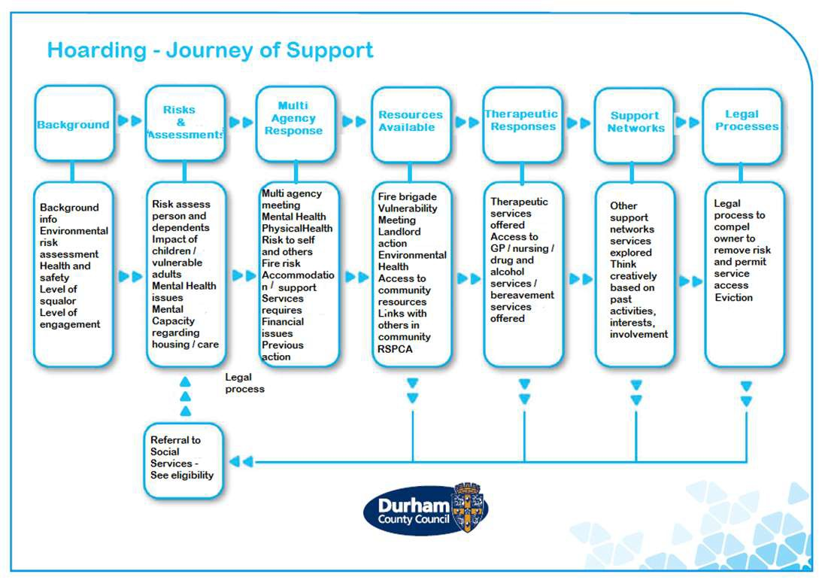

Engage and carry out a multi- disciplinary needs assessment
Do they accept treatment?
Do they have a mental illness?
NO

Continue follow-up and supervision to prevent
Consider using the Mental Health Act 1983 if appropriate

Mental Capacity Act Assessment

IMCA

Lasting Power of attorney

Deputy
Not known

NO
Individual
Resists
Assessment
Or help

Can make Best Interests decisions about interventions
(Including cleaning and medical treatment) and about payments
Do they have capacity?

Continue to liaise and discuss help options available

If unsuccessful consider alternative services:

Environmental Health, RSPCA, Police, Animal welfare, Risks to neighbours, Tenants themselves

Cannot assess because person refuses to open door or speak to anyone.
Consider:

Relationship with others (GP, relatives, neighbours)

MHA assessments (S135 police warrant)

Register social landlord powers under the Housing Act 1988 to compel a tenant access to property for inspection

Use appropriate legislation (determined by property ownership) to compel owner/ occupant to remove risk and permit access

Substantial Problem

Risk to wellbeing refer to Social Services

